**The determinants of dividend payout policies**

**Aurora De Gaspari, Laura Paoletti, Daniele Veggiato**

**Empirical Corporate Finance 2019/2020**

**ISEG, Lisbon**

**ABSTRACT**

This paper aims to identify the determinants of dividend payout ratios. We select from the literature eight important factors that may be instrumental in affecting the dividend payout decision, i.e. profitability, cash flow, corporate tax, sales growth, price-to-book ratio, debt-to-equity ratio, size, life-cycle stage. We study such variables conducing a panel data analysis on 156 companies listed in the EURONEXT (Paris, Amsterdam, Bruxelles, Lisbon) for the period from 2009 to 2018. Our findings show ROA, net cash flow from operating activities and debt-to-equity ratio affect dividend payout positively; on the contrary, the effective tax rate and the life-cycle stage have a negative marginal effect on dividend payout.

**1. INTRODUCTION**

When it comes to firms’ preferences about dividend distribution, they seem to display a rather high degree of heterogeneity. This consideration motivated the interest for this research, whose purpose is to investigate the determinants of dividend payout ratios.

In order to select factors that may affect the dividend payout decisions we decided to base our investigation on those identified in two specific works. Gill, Biger and Tibrewala (2010) base their analysis on American service and manufacturing firms. Looking at the results, they find that the dividend payout ratio is a function of profit margin, sales growth, debt-to-equity ratio, and tax. The study conducted by Arif and Akbar (2013) on non-financial sector of Pakistan identifies profitability, tax and size as most influential determinants of dividend policy.

Based on the papers just mentioned, we run panel OLS regressions in order to test the significance of the following factors in the determination of the dividend payout ratio (*DP*): ROA (*PROF*), net cash flow from operating activities (*CF*), effective tax rate (*CORP_TAX*), sales growth (*SALES*), price-to-book ratio (*PTB*), debt-to-equity ratio (*DTE*), total assets (*SIZE*), life-cycle stage (*LIFE_CYCLE*). (See Table 1 for an accurate definition of each variable.) Throughout all our work, we assume a significance level for every test of 5%.

The report is organized as following: Section II presents our dataset; in Section III we report the results from the OLS estimation and we perform some post estimation diagnostics; Section IV concludes.

**2. DATA**

**2.1. Data collection**

To conduct our study, we selected a sample of 156 firms listed in the EURONEXT for the period from 2009 to 2018. We collected the data from Thomson Reuters. In particular, we decided to select firms quoted in the EURONEXT markets of Paris, Amsterdam, Brussels and Lisbon, taking into consideration ordinary shares and active primary quotes only.

**2.2. Data preparation**

First, we drop missing data and to have an overview of the dataset we plot the histogram of our sample (Figure 1). The distribution, compared to a normal distribution, seems skewed to the right and shows some extreme values.

To reduce the effect of possible outliers, we apply a Winsor transformation to the data, limiting extreme values in the distribution. Subsequently, since the descriptive statistics of our new variable are still not satisfactory, we consider it appropriate to drop extreme values beyond the minimum and the maximum (Table 2).

Another issue affecting our sample is that it includes the years of the financial crisis. To avoid possible biases due to the distorted data that might have been registered during the crisis, we generate a control variable that takes the value of 1 if the data refer to the year 2008 or 2009. However, such variable results non-significant since it does not relevantly influence our dependent variable, as reported in Table 3. For this reason, we do not add it in the regression.

Finally, we conclude the preparation of the dataset by dropping the companies for which we have less than 8 observation. A panel dataset that is too unbalanced might, otherwise, cause possible issues in the following analysis. After winsorising the dependent variable and dropping the outliers, the remaining sample includes 1408 observations from 156 firms and its distribution seems to approximate a normal more smoothly than the starting one, as highlighted by the histogram in Figure 2.

We acknowledge about the possible selection bias that may affect our research, but the choice of dropping those observations was made necessary to consistently apply an OLS model to our data.

**2.3. Descriptive statistics**

The descriptive statistics of the dependent variable shows that the skewness index has improved, even if some light right skewness is still present. The tails of the distribution do not seem problematic, since the kurtosis is below 3.

Subsequently we plot a scatterplot matrix (Figure 3) to determine possible linear correlations between the variables. By looking at the plot we can pinpoint some specific variable that might be problematic in terms of multicollinearity. More specifically, the variables *SIZE* and *CF* might trigger some issue, even though we underline that this is just a rough graphical overview of our sample that still has to be tested.

To conclude the diagnostic on our data and assess whether the distribution is normal, we plot the quantile-quantile plot (Figure 4) and the normal probability plot (Figure 5). The results seem consistent with the hypothesis of normality of the data.

**3. ESTIMATION**

**3.1. Model selection**

We show the results obtained with different models in Table 4. The model in Column (1) includes all the explanatory variables as defined in Table 1. The one in Column (2) excludes those causing multicollinearity issues (*PTB* and *SIZE*; see Subsection 3.2). We further dropped not significant variables (*SALES*) to obtain Column (3), which we will take as our baseline model. In Column (4) standard errors are clusterised by economic sector, causing some variables to lose significance. Clusterising by country does not get to any significant model; therefore, we did not show that specification in the table. Column (5), Column (6), Column (7) and Column (8) display fixed effects models including, respectively, only time, only firm, both time and firm, and all the possible effects (time, firm, economic sector and country). We show the results from a random effect model in Column (9). Finally, in Column (10) we adopt Driscoll-Kraay standard errors to account for any cross-sectional and temporal dependence that we could not control for in the previous models.

The model in Column (3) shows an adjusted R-squared of 0.110. Moreover, only pooled OLS models achieve normality of residuals. Fixed effects models capture a higher fraction of the variability in the data (adjusted R-squared reaches 0.430 in the model with both time and firm effects); however, all these models fail to achieve normality of residuals (see Subsection 3.2). It is important to underline that the non-normality of residuals implies that the model with fixed effect is inadequate to represent our data. Consequently, the results obtained from the analysis of such models do not have a great degree of reliability. Therefore, we feel more confident in taking the model in Column (3) as baseline, since it ensures BLUE properties of OLS estimator.

Nevertheless, we observe a few interesting features of fixed effects models. The contribution of this estimation method mainly comes from the individual firm fixed effect. When moving from the model in Column (5) (only time effects) to that in Column (6) (only firm effects), we see a big improvement in the adjusted R-squared; adding economic sector and country effects does not improve further the goodness-of-fit. This suggests including firm fixed effects captures more adequately time-invariant heterogeneity in our data. Furthermore, *CF* and *CORP_TAX* become not significant anymore, while *PROF* strikingly changes from a positive to a negative sign. This means *PROF* has a positive *overall* impact on the dependent variable, but a negative *within group* impact (i.e. when controlling for unobserved time-invariant heterogeneity across firms).

Finally, many variables in the random effects model are not significant. Indeed, we will confirm the dominance of fixed effects models in the next subsection.

**3.2. Post-estimation diagnostics**

First, we show the consistency of our baseline model by reporting some graphs (Figures 6 and 7) and tests on the residuals. The Shapiro-Wilk test fails to reject the null hypothesis of normality of residuals (Table 5). Therefore, we assume BLUE properties of the OLS estimator are valid. In general, all the models we obtained by pooled OLS achieve normality of residuals.

We then check for multicollinearity issues among all the original explanatory variables. The correlation matrix (Table 6) shows strong correlations between *PROF* and *PTB* and between *CF* and *SIZE*, thus partially confirming our concerns. Intuitively, it makes sense these two couples to correlate. High profitability can motivate a high market value attached by investors to a stock compared to its book value. The cash flows a company can generate in absolute terms surely correlate with the absolute value of the company’s assets. Again, the VIF test in Table 7 confirms the evidence arising from the correlation matrix. Hence, after having run the preliminary regression in Column (1), in Column (2) we dropped *PTB* and SIZE, because they appear less significant than *PROF* and *CF*, respectively.

We then run a Breusch-Pagan test on some of our models. The test rejects the null hypothesis of homoscedasticity for the models estimated by pooled OLS (Table 8), while it fails to reject for fixed effects models (Table 9). Nevertheless, we always use robust standard errors to be consistent throughout all the models comparison.

Since all the models from Column (3) to Column (10) in Table 4 are based on the same explanatory variables, we perform the following tests on the independent variables on the baseline model only, the results for fixed effects models being similar. The Wald test in Table 10 rejects the null hypothesis of the independent variables being not significant. On the other hand, the Ramsey test rejects the null hypothesis of correct specification, thus suggesting the presence of omitted variables and potential endogeneity issues (Table 11). Nonetheless, the link test fails to reject the null hypothesis of correct specification (Table 12). While acknowledging the potential endogeneity issues that may affect our research, we decided not to investigate further these issues and assume our baseline model is correctly specified for three reasons. First, the two tests producing opposite results makes the decision on the potential misspecification arguable. Second, while considering dealing with endogeneity by using a diff-in-diff estimation, we also believe our research question is unsuited for the quasi-experimental approach implied by this technique (e.g. in terms of control and treatment group, division point); therefore, we drop this possibility. Third, we are still encouraged to go ahead with our baseline model because it achieves normality of residuals, thus ensuring consistency of our estimates.

Finally, we test whether fixed effects models are more appropriate than a random effects model, as we suspected from the estimation output in Table 4. The Hausman test (Table 13) corroborates our idea, rejecting the null hypothesis of a random effects model being consistent and more efficient than a fixed effects model.

**3.3. Interpretation of the coefficients**

Once we have validated the statistical significance and the consistency of our baseline model, in this last subsection we provide a few observations about the empirical results we get from its estimation, as presented in Column (3) of Table 4. The reader can find the interpretation for each coefficient in Table 14.

First, we find ROA (*PROF*), net cash flow from operating activities (*CF*) and debt-to-equity ratio (*DTE*) affect dividend payout positively. Firms that are more profitable, liquid and leveraged tend to distribute a higher fraction of earnings as dividends to common shareholders.

On the other hand, the effective tax rate (*CORP_TAX*) and the ratio of retained earnings over total equity (*LIFE_CYCLE*) have a negative marginal effect on dividend payout. Firms bearing higher taxation or more mature firms tend to distribute a lower fraction of income as dividends to their shareholders. We find some support to the negative sign of this coefficient in Arif and Akbar (2013), despite their result not being significant.

**4. Conclusions**

In this work we analysed a panel dataset of 156 listed firms from EURONEXT (Paris, Amsterdam, Bruxelles, Lisbon) covering the period 2009 – 2018. The objective of our analysis was to identify the determinants of dividend payout. To accomplish our research question, we adopted a pooled OLS model as baseline. In order to ensure the consistency of OLS estimation, we modelled our data to smooth the original distribution towards a normal one.

We found ROA, net cash flow from operating activities and debt-to-equity ratio to affect dividend payout positively; on the contrary, the effective tax rate and the life-cycle stage have a negative marginal effect on dividend payout.

We are aware of the limits of our research. We know the transformations we applied to our data are susceptible of selection bias. Moreover, we observe our model may suffer from omitted variables issues. Nevertheless, our results seem to find support from economic theories and are certainly to be explored in a more analytical fashion.

**REFERENCES**

Arif, A., & Akbar, F. (2013). Determinants of dividend policy: a sectoral analysis from Pakistan. *International Journal of Business and Behavioral Sciences*, *3*(9), 16-33.

Bulan, L. T., & Subramanian, N. (2009). The firm life cycle theory of dividends. *Dividends and dividend policy*, 201-213.

Gill, A., Biger, N., & Tibrewala, R. (2010). Determinants of dividend payout ratios: evidence from United States. *The Open Business Journal*, *3*(1).

**APPENDIX A**

**TABLES**

**Table 1. Definition of the variables.**

|  |  |
| --- | --- |
| **Variables** | **Definitions** |
| PROF | EBIT / Total assets |
| CF | ln (Operating cash flow) |
| CORP_TAX | Corporate tax / Net profit before tax |
| SALES | (Current sale – Previous sales) / Previous sales |
| PTB | Market capitalisation / Total equity |
| DTE | Total debt / Total equity |
| SIZE | ln (Total assets) |
| LIFE_CYCLE | Retained earnings / Total equity |
| LN_DP | ln (Year dividend / Net income after tax) |

**Table 2. Descriptive statistics for the Winsorised dividend payout (*WLN_DP*).**

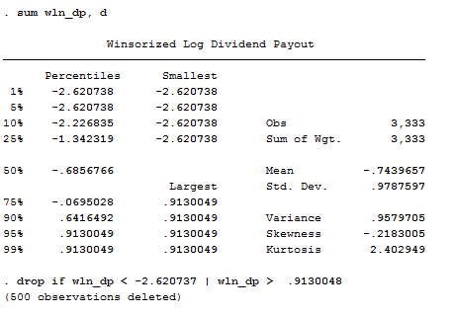

**Table 3. Significance test on the financial crisis dummy (*FINCRISIS*).**

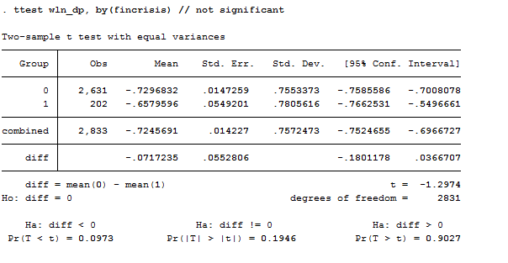

**Table 4. Regression results.**

|  |  |  |  |  |  |  |  |  |  |  |
| --- | --- | --- | --- | --- | --- | --- | --- | --- | --- | --- |
|  | (1) | (2) | (3) | (4) | (5) | (6) | (7) | (8) | (9) | (10) |
|  | Pooled OLS | Pooled OLS | Pooled OLS  (baseline) | Pooled OLS (clusters by sector) | Time F.E. | Firm F.E. | Time and firm F.E. | Time, firm, sector and country F.E. | R.E. | Pooled OLS (Driscoll-  Kraay) |
| PROF | 0.945** | 1.369*** | 1.282*** | 1.282** | 1.344*** | -2.025*** | -1.764** | -1.764** | -0.242 | 1.282*** |
|  | (0.476) | (0.298) | (0.291) | (0.417) | (0.295) | (0.714) | (0.750) | (0.750) | (0.624) | (0.232) |
| CF | 0.035 | 0.041*** | 0.040*** | 0.040* | 0.040*** | -0.003 | -0.012 | -0.012 | 0.023 | 0.040*** |
|  | (0.029) | (0.009) | (0.009) | (0.019) | (0.009) | (0.030) | (0.032) | (0.032) | (0.015) | (0.007) |
| CORP_TAX | -0.013** | -0.015*** | -0.014** | -0.014 | -0.015*** | 0.001 | -0.000 | -0.000 | -0.004 | -0.014 |
|  | (0.006) | (0.006) | (0.006) | (0.009) | (0.006) | (0.008) | (0.007) | (0.007) | (0.009) | (0.008) |
| SALES | -0.322 | -0.321 |  |  |  |  |  |  |  |  |
|  | (0.204) | (0.203) |  |  |  |  |  |  |  |  |
| PTB | 0.024 |  |  |  |  |  |  |  |  |  |
|  | (0.018) |  |  |  |  |  |  |  |  |  |
| DTE | 0.057*** | 0.062*** | 0.060*** | 0.060* | 0.060*** | 0.108*** | 0.111*** | 0.111*** | 0.074*** | 0.060*** |
|  | (0.012) | (0.012) | (0.012) | (0.026) | (0.012) | (0.030) | (0.032) | (0.032) | (0.023) | (0.009) |
| SIZE | 0.004 |  |  |  |  |  |  |  |  |  |
|  | (0.031) |  |  |  |  |  |  |  |  |  |
| LIFE_CYCLE | -0.600*** | -0.598*** | -0.589*** | -0.589*** | -0.606*** | -0.535*** | -0.678*** | -0.678*** | -0.490*** | -0.589*** |
|  | (0.060) | (0.060) | (0.059) | (0.089) | (0.059) | (0.161) | (0.173) | (0.173) | (0.100) | (0.053) |
| Constant | -1.230*** | -1.246*** | -1.242*** | -1.242*** | -1.184*** | -0.060 | 0.200 | 0.200 | -0.903*** | -1.242*** |
|  | (0.240) | (0.164) | (0.166) | (0.291) | (0.174) | (0.571) | (0.616) | (0.616) | (0.268) | (0.085) |
|  |  |  |  |  |  |  |  |  |  |  |
| Year | no | no | no | no | yes | no | yes | yes | no | no |
| Firm | no | no | no | no | no | yes | yes | yes | no | no |
| Sector | no | no | no | no | no | no | no | yes | no | no |
| Country | no | no | no | no | no | no | no | yes | no | no |
|  |  |  |  |  |  |  |  |  |  |  |
| Obs. | 1356 | 1356 | 1356 | 1356 | 1356 | 1356 | 1356 | 1356 | 1356 | 1356 |
| R-squared | 0.129 | 0.128 | 0.114 | 0.114 | 0.126 | 0.490 | 0.501 | 0.501 | - | 0.114 |
| Adjusted R-squared | 0.124 | 0.124 | 0.110 | 0.110 | 0.117 | 0.421 | 0.430 | 0.430 | - | - |
| F | 23.190 | 30.905 | 36.145 | 35.875 | 15.555 | 17.182 | 17.614 | 17.614 | - | 1993.223 |
| Column (1): pooled OLS on all the explanatory variables. Column (2): pooled OLS on all the explanatory variables less those causing multicollinearity issues. Column (3) (baseline model): pooled OLS on all the explanatory variables less those causing multicollinearity issues or not significant. Column (4): pooled OLS on the baseline model with standard errors clusterised by economic sector. Column (5): OLS on the baseline model with time fixed effects. Column (6): OLS on the baseline model with firm fixed effects. Column (7): OLS on the baseline model with both time and firm fixed effects. Column (8): OLS on the baseline model with both time, firm, industry and country fixed effects. Column (9): GLS on the baseline model with random effects. Column (10): pooled OLS on the baseline model with Driscoll-Kraay standard errors.  Robust standard errors are in parenthesis. | | | | | | | | | | |
| *\*\*\* p<0.01, ** p<0.05, * p<0.1* | | | | | | | | | | |

**Table 5. Shapiro-Wilk test on the residuals from the baseline regression.**

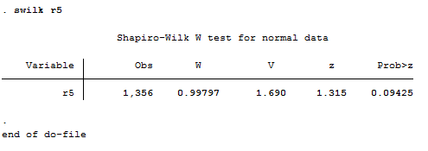

**Table 6. Correlation matrix.**

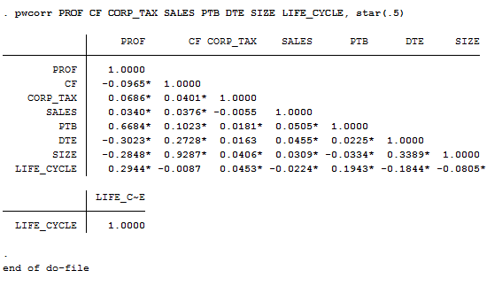

**Table 7. VIF test.**

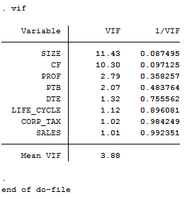

**Table 8. Breusch-Pagan test on the baseline regression.**

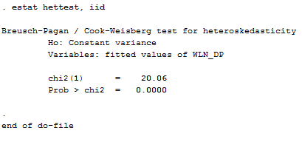

**Table 9. Breusch-Pagan test on the fixed effects model in Column (7) (time and firm fixed effects).**

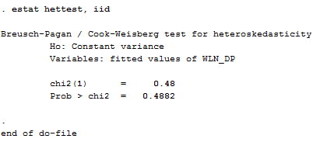

**Table 10. Wald test on the explanatory variables included in the baseline model.**

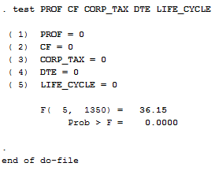

**Table 11. Ramsey test on the baseline specification.**

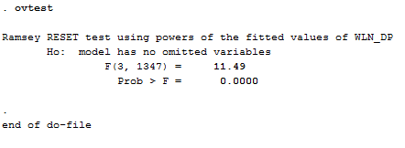

**Table 12. Link test on the baseline specification.**

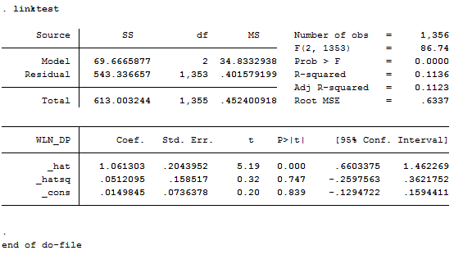

**Table 13. Hausman test.**

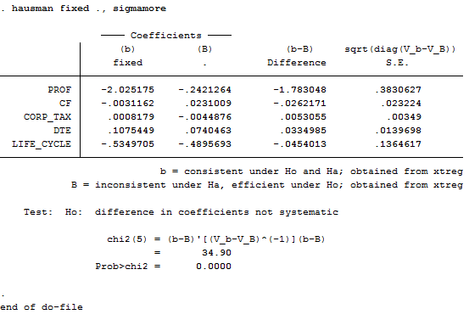

**Table 14. Interpretation of the marginal effects.**

|  |  |  |  |  |  |
| --- | --- | --- | --- | --- | --- |
| *x* | Functional form | Interpretation | Coefficient | *∆x* | *∆DP* |
| PROF | Linear (ratio) | Semi-elasticity | 1.282 | 0.01 | 1.282% |
| CF | Log (absolute) | Elasticity | 0.040 | 1% | 0.040% |
| CORP_TAX | Linear (ratio) | Semi-elasticity | -0.014 | 0.01 | -0.014% |
| DTE | Linear (ratio) | Semi-elasticity | 0.060 | 0.01 | 0.060% |
| LIFE_CYCLE | Linear (ratio) | Semi-elasticity | -0.589 | 0.01 | -0.589% |

The dependent variable we consider here is the dividend payout ratio (*DP*), without the logarithmic transformation. *x* represents each factor affecting the dividend payout. *Functional form* is the form we chose for each explanatory variable in our baseline model. *∆DP*is then the change in dividend payout corresponding to a change in each explanatory variable by *∆x*, ceteris paribus.

**APPENDIX B**

**FIGURES**

**Figure 1. Distribution of the logarithm of dividend payout (*LN_DP*).**

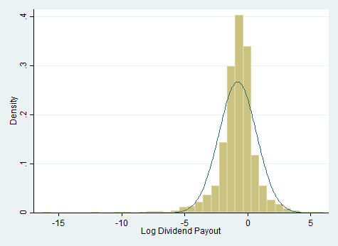

**Figure 2. Distribution of the Winsorised logarithm of dividend payout, after omitting Winsorised values (*WLN_DP*).**

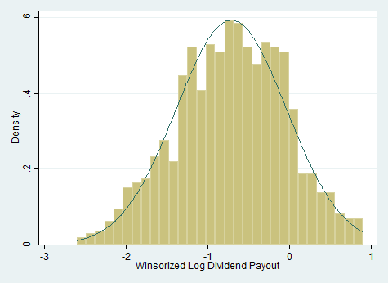

**Figure 3. Scatterplot matrix.**

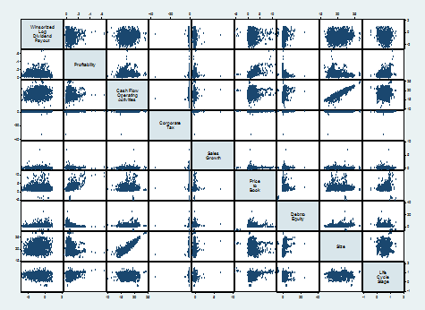

**Figure 4. Quantile-quantile plot of *WLN_DP*.**

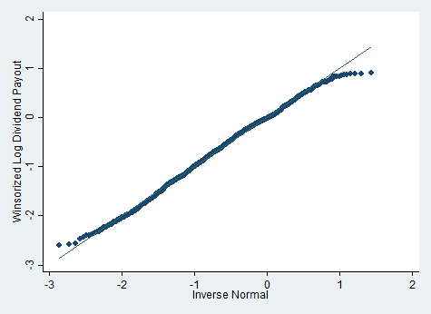

**Figure 5. Normal probability plot of *WLN_DP*.**

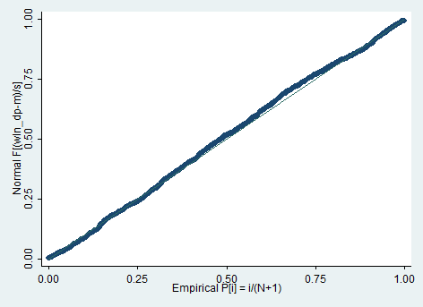

**Figure 6. Kernel density plot of the residuals from our baseline regression.**



**Figure 7. Normal probability plot of the residuals from our baseline regression.**

